## ASSIGNMENT: ANSWERINGQUESTION

DR.MOHAMMED AWADH BEN MUBARAK

INFRASTRUCTURE UNIVERSITY KULAL LUMPUR

Email: awadh@iukl.edu.my

*MOHAMMAD OBYDUR RAHMAN*

*MASTER INFORMATION TECHNOLOGY*

*INFRASTRRE UNIVERSITY KUALA LUMPUR*

*ID: 153915771 Email:obydur69@gmail.com*

## 1. What advantage does a circuit-switched network have over a packet-switched network? What advantages does TDM have over FDM in a circuit-switched network?

Circuit switching and packet switching are both networking methods for transferring data between two host or end devices. These switch have an advantages in the following table.

|  |  |
| --- | --- |
| Circuit switch | Packet switch |
| Performance guaranteed | Resources sharing |
| Dedicated resources like no sharing, no interference | Store and forward |
| Quality of service from one to another pc |  |
| Call setup required | No call setup |

In the following way, there are some advantage of TDM and FDM.

|  |  |
| --- | --- |
| TDM | FDM |
| TDM provides flexibility and efficiency with dynamic allocating | FDM is an analogy multiplexing technique. |
| Reducing the time periods | Its concept of modulation |
| Bandwidth saving | No need dynamic coordination. |

2. Consider sending a packet from a source host to a destination host over a fixed route. List the delay components in the end-to-end delay. Which of these delays are constant and which are variable?

There are four components delay like propagation delay, transmission delay, queueing delay and nodal processing delay. All of these delay are constant without queueing delay .so queueing delay is a variable.

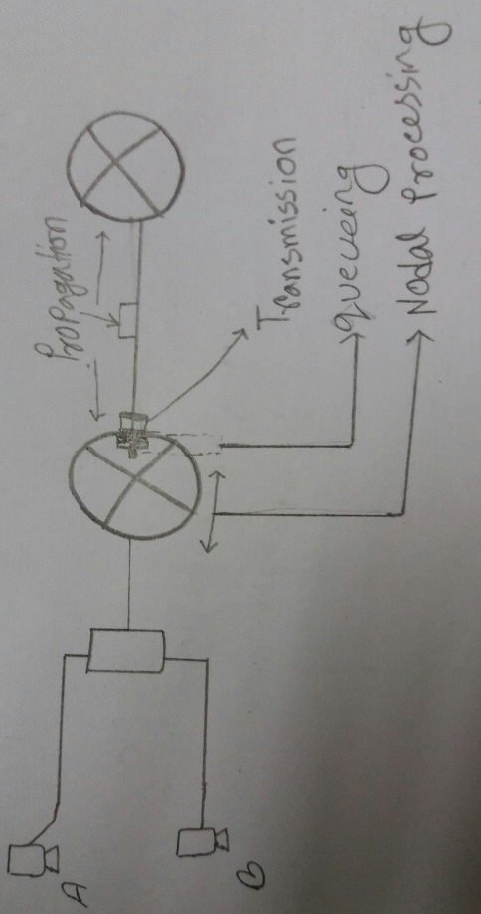

**Propagation delay:**

1. Propagation delay= d/s = length of physical link/ propagation speed in medium.
2. Propagation delay is an amount of time.

**Transmission delay:**

1. Transmission delay= L/R = packet length (bits)/ link bandwidth(bps)
2. Store and forward delay is the amount of time required to push all of the packets bits into the wire.

**Queueing delay:**

1. it waits to be transmitted onto the link.
2. Depends on congestion level of router.

**Nodal processing delay:**

1. It takes for a router to process packet header by checking bit errors and determining the output link.

3. Suppose Host A wants to send a large file to Host B. The path from Host A to Host B has three Jinks, of rates R 1 = 500 kbps, R2 = 2 Mbps, and R3 = I Mbps.

a. Assuming no other traffic in the network, what is the throughput for the file transfer.

b. Suppose the file is 4 million bytes. Dividing the file size by the through put, roughly how long will it take to transfer the file to Host B?

c. Repeat (a) and (b), but now with R2 reduced to 100 kbps.

(a)Throughput=500kbps(as it is the lowest path)

(b) Here, file size L=4million bytes=4*1000000*8=32000000 bits

Throughput(R) =500kbps=500000mbps

We know, transfer file=L/R=32000000/500000=64s

(c) Throughput=100kbps(according R1=500kbps,R2=100kbps,R3=1Mbps)

Transfer file=L/R=4000000*8/100000=320s

4. Consider an application that transmits data at a steady rate (for example, the sender generates an N-bit unit of data every k time units, where k is small and fixed). Also, when such an application starts, it will continue running for a relatively long period of time. Answer the following questions, briefly justifying your answer:

a. Would a packet-switched network or a circuit-switched network be more appropriate for this application? Why?

b. Suppose that a packet-switched network is used and the only traffic in this network comes from such applications as described above. Furthermore, assume that the sum of the application data rates is less than the capacities of each and every link. Is some form of congestion control needed? Why?

a) A circuit-switched network will be more appropriate for this application for the reason

* The application consist of long sessions with anticipated or predicted uniform bandwidth requirements.
* The transmission rate is identified therefore bandwidth can be reserved for each application session circuit with no significant waste.
* Consequently, overhead costs of setting up and tearing down a circuit connection are reduced over the prolonged duration of a typical application session.

b) With the above known substantial link capacities, the network needs no congestion control mechanism. In a situation of most potentially congested case, all the applications simultaneously transmit over one or more particular network links. However, since each link offers sufficient bandwidth to handle the sum of all of the applications' data rates, no congestion or very little queuing will occur.

5. Suppose you would like to urgently deliver 40 terabytes data from Boston to Los Angeles. You have available a 100 Mbps dedicated link for data transfer. Would you prefer to transmit the data via this link or instead use FedEx overnight delivery? Explain

We know using a dedicated link=L/R

Here data L=40*1000*1000*1000*1000*8bits=320000000000000bits

Data transfer rate R=100mbps=100*1000*1000

So, using dedicated link=L/R=320000000000000/100000000=3200000seconds=37days.

6. For a communication session between two hosts, which host is the client and which is the server?

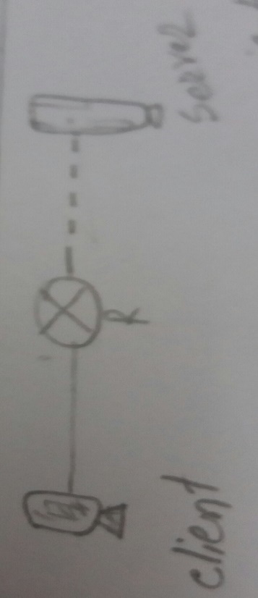

The first initiates the communication is the client, the process which awaits to be connected is server.

7. What information is used by a process running on one host to identify a process running on another host?

* First IP address of the destination host.
* Port number of the destination socket.

8. Suppose you want to do a transaction from a remote client to a server as fast as possible. Would you use UDP or TCP? Why?

There are several reason why I use UDP

* The transaction can be completed in RTT(Round trip time)
* The client sends the transaction request into a UDP socket while the server sends the reply back to the clients UDP socket.

When I used TCP for the reason

* Setup the TCP connection
* The client to send the request and server back the reply.

9. Describe how Web caching can reduce the delay in receiving a requested object. Will Web caching reduce the delay for all objects requested by a user or for only some of the objects? Why?

Web caching can bring the desired content closer to the user, possibly to the same LAN to which the user’s host is connected. Web caching can reduce the delay for all objects, even objects that are not cached, since caching reduces the traffic on links.

10. What is the overlay network? Does it include routers? What are the edges in the overlay network? How is the query flooding overlay network created and maintained?

1. An overlay network is a computer network which is built on the top of another network whereas the overlay network in a p2p file sharing system between n-devices.
2. No, an overlay network does not include routers.
3. Edges are the connections between peers.one edges is connection between two peers, regardless of the physical links between n-to n devices.
4. Query flooding is simple to implement and is practical for small networks with few requests. If peer X maintains a TCP connection with another peer Y, then we say there is an edge between X and Y. An edge in overlay is simply the TCP connection between a peer.

11. For the client-server application over TCP, why must the server program be executed before the client program? For the client server application over UDP, why may the client program be executed before the server program?

1. Client usually requests to server or server provides.

2. TCP is a connection oriented model and before data transfer. TCP have a three way like handshake, connection to server and client ends

3. For sending data, sender simply drop the data into the TCP connection via socket; unless UDP which has to attach destination address. The 3-way handshake enables the TCP connection to make a way i.e. a socket, which will accept the data arrival from client side.

12. Consider an HTTP client that wants to retrieve a Web document at a given URL. The IP address of the HTTP server is initially unknown. What transport and application-layer protocols besides HTTP are needed in this scenario?

* I need to obtain an ip address. So DNS server need for finding hosting name under ip address.as we know that DNS runs over UDP. While HTTP makes a TCP connection with the server. Finally

1. application layer protocols : DNS and HTTP
2. Transport layer protocol: TCP connection for HTTP and UDP connection for DNS.

13. Suppose the network layer provides the following service. The network layer in the source host accepts a segment of maximum size 1,200 bytes and a destination host address from the transport layer. The network layer then guarantees to deliver the segment to the transport layer at the destination host. Suppose many network application processes can be running at the destination host.

a. Design the simplest possible transport-layer protocol that will get application data to the desired process at the destination host. Assume the operating system in the destination host has assigned a 4-byte port number to each running application process.

b. Modify this protocol so that it provides a "return address" to the destination process.

c. In your protocols, does the transport layer "have to do anything" in the core of the computer network?

1. At the sender side, STP accepts from the sending process a chunk of data exceeding 1196 bytes with a destination host address and the destination port number. STP adds a four byte header to each chunk and puts the port number of the destination process in this header. STP then gives the destination host address and the resulting segment of the network layer. The network layer delivers the segment to STP at the destination host. STP then examines the port number in the segment, extracts the data from the segment and passes the data to the process identified by the port number.
2. The segment now has two header fields: a source port field and destination port field. At the sender side, STP accepts a chunk of data not exceeding 1192 bytes, a destination host address, a source port number and a destination port number. STP creates a segment which contains the application data, source port number and destination port number. It then give segment and destination host address to the network layer. After receiving the segment, STP at the receiving host gives the application process the application data and the source port number.
3. No, transport layer does not have to do anything in the core; the transport layer lives in the end systems.

14. Consider a TCP connection between Host A and Host B. Suppose that the TCP segments traveling from Host A to Host B have source port number x and destination port number y. What are the source and destination port numbers for the segments traveling from Host B to Host A?

Host B to host A : source port number y and destination port number x.

15. Describe why an application developer might choose to run an application over UDP rather than TCP.

There are several reason why developer choose to run an application over UDP rather than TCP in the flowing way.

* UDP is a connectionless oriented as a result it can be support more clients with less overhead.
* May be it is faster than TCP .
* It is suitable for broadcasting and multi-casting because it is no connection orientated.
* It is flexible than TCP during implementation
* We can control the sending rate in UDP.

16. Is it possible for an application to enjoy reliable data transfer even when the application runs over UDP? If so, how?

Yes, it is possible. The application developer can put reliable data transfer into the application layer protocol.

17. Suppose that a Web server runs in Host C on port 80. Suppose this Web server uses persistent connections, and is currently receiving requests from two different Hosts, A and B. Are all of the requests being sent through the same socket at Host C? If they are being passed through different sockets, do both of the sockets have port 80? Discuss and explain.

Port 80 is used only for the initial connection. And this keeps port 80 free for new incoming request.

18. Suppose Host A sends two TCP segments back to back to Host B over a TCP connection. The first segment has sequence number 90; the second has sequence number 110.

**a)** How much data is in the first segment? **b)** Suppose that the first segment is lost but the second segment arrives at B. In the acknowledgment that Host B sends to Host A, what will be the acknowledgment number? **c)** Suppose that the first segment is lost but the second segment arrives at B. In the acknowledgment that Host B sends to Host A, what will be the acknowledgment number?

a) Data size=110-90=20bytes

b) Acknowledgement=90

c) Acknowledgement=90.

19. Suppose Client A initiates a Telnet session with Server S. At about the same time. Client B also initiates a Telnet session with Server S. Provide possible source and destination port numbers for

a) The segments sent from A to S. (b) The segments sent from B to S. (c) The segments sent from S to A. (d) The segments sent from S to B. (e) If A and B are different hosts, is it possible that the source port number in the segments from A to S is the same as that from B to S! (f) How about if they are the same host?

|  |  |  |
| --- | --- | --- |
| Question no | Source port no | Destination port no |
| A | 467 | 23 |
| B | 567 | 23 |
| C | 23 | 467 |
| D | 23 | 567 |
|  |  |  |

(e) yes it is possible because different ip

(f) no it is no possible as one host have a one port number.

20. UDP and TCP use 1’s complement for their checksums. Suppose you have the following three 8-bit bytes: 01010011, 01010100 and 01110100. What is the 1’s complement of the sum of these 8-bit bytes?

01010011

+01010100

|  |  |
| --- | --- |
| 10100111  +01110100 |  |
| (1)00011011  + 1 | 1 is a carry mark’s |
| 00011100 |  |
| 1’s complement is therefore=11100011 |  |
|  |  |

**21. Consider transferring an enormous file of L bytes from Host A to Host B. Assume an MSS of 536 bytes.**

**a) What is the maximum value of L such that TCP sequence numbers are not exhausted? Recall that the TCP sequence number field has 4 bytes.**

**b) For the L you obtain in (a), Find how long it takes to transmit .the file. Assume that a total of 66 bytes of transport, network, and data-link header are added to each segment before the resulting packet is sent out over a 155 Mbps link. Ignore flow control and congestion control so A can pump out the segments back to back and continuously.**

1. 1 byte=8bits so 4 bytes =4*8=32bits

Therefore $2^{32}=4294967296$ possible sequence number but MSS = 536 bytes are irrelevant number, we cannot send this file from host A to host B. The maximum file size is.

1. Here 232 bytes / 536 bytes = 8, 012, 999. Each segment, a header of 66 bytes is added and the total number of bytes to transfer becomes

L = (536+66 bytes) * 8, 012, 999 bytes = 4,823,825,398 bytes. The 155 Mbps link, the time needed to transfer L bytes=L * 8 bit / (155 * 106) bit/s ≈ 249 s. Therefore it would take 249 seconds to transmit the file over a 155 Mbps link.

22. Host A and B are communicating over a TCP connection, and Host B has already received from A all bytes up through byte 126. Suppose Host A then sends two segments to Host B back-to-back.

The first and second segments contain 70 and 50 bytes of data, respectively. In the first segment, the sequence number is 127, the source port number is 302, and the destination port number is 80. Host B sends an acknowledgement whenever it receives a segment from Host A.

1. In the second segment sent from Host A to B, what are the sequence number, source port number, and destination port number?
2. If the first segment arrives before the second segment, in the acknowledgement of the first arriving segment, what is the acknowledgment number, the source port number, and the destination port number?
3. If the second segment arrives before the first segment, in the acknowledgement of the first arriving segment, what is the acknowledgment number?
4. Suppose the two segments sent by A arrive in order at B. The first acknowledgement is lost and the second acknowledgement arrives after the first timeout interval. Draw a timing diagram, showing these segments and all other segments and acknowledgements sent. (Assume there is no additional packet loss.) For each segment in your figure, provide the sequence number and the number of bytes of data; for each acknowledgement that you add, provide the acknowledgement number.

1. The sequence number is 127+70=197 and source port is 302 and destination port number is 80.
2. Acknowledgement number is 197, source port number is 80 and destination port number is 302.
3. Acknowledgement number is 127 and bytes 127 for waiting.
4. This is the figure 1.2(d) in the following way. 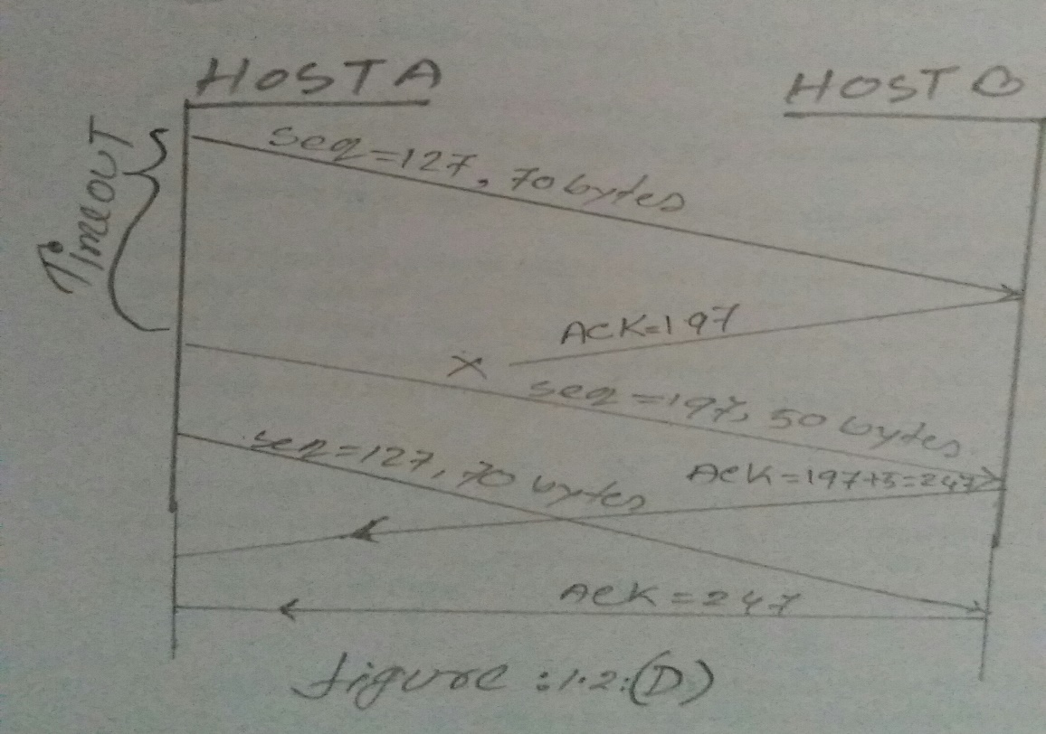

23. Host A and B are directly connected with a 100 Mbps link. There is one TCP connection between the two hosts, and Host A is sending to Host B an enormous file over this connection. Host A can send its application data into its TCP socket at a rate as high as 120 Mbps but Host B can read out of its TCP receive buffer at a maximum rate of 60 Mbps. Describe the effect of TCP flow control.

According to the question, Host A will be sending data into it faster than Host B can remove the data from it. Once the buffer has completely filled, Host B will send a message to Host A to stop sending data until Host B can remove data from the buffer. Host B will then send a TCP segment to Host A, informing it to continue sending data. The buffer will fill up again and this process will repeat until all of the data has been sent from Host A to Host B.

24. Consider that only a single TCP (Reno) connection uses one 10 Mbps link which does not buffer any data. Suppose that this link is the only congested link between the sending and receiving hosts. Assume that the TCP sender has a huge file to send to the receiver, and the receiver's receive buffer is much larger than the congestion window. We also make the following assumptions: each TCP segment size is 1,500 bytes; the two-way propagation delay of this connection is I 00 msec; and this TCP connection is always in congestion avoidance phase, that is, ignore slow start.

a) What is the maximum window size (in segments ;) that this TCP connection can achieve'?b) What is the average window size (in segments) and average throughput (in bps) of this TCP connection?c) How long would it take for this TCP connection to reach its maximum window again after recovering from a packet loss?

a) W*1500/RTT = 10M/8 => W = 83.3 segments

b) Because the connection always works under congestion avoidance,

Average window size = 83*0.75 = 63 segments; (0.75W = average of (W/2+W))

Average throughput = 10M * 0.75 = 7.5MB

c) About 84/2 RTT, or precisely 42 RTT = 4.2sec.

25. Do the routers in both datagram networks and virtual-circuit networks use forwarding tables? If so, describe the forwarding tables for both classes of networks.

Yes, both use forwarding tables. The columns are virtual circuit for forwarding table like incoming interface, incoming virtual circuit number, outgoing interface and outgoing virtual circuit number whereas the columns are a datagram forwarding table: outgoing interface and destination address.

26. Three types of switching fabrics are discussed in course. List and briefly describe each type.

There are three types of switching fabrics like:

1. Switching via memory
2. Switching via a bus
3. Switching via an interconnection network

**Switching via memory:** At the first generation of computer and switch or router under direct control of CPU. The packets are copied to system’s memory and its speed was limited by memory bandwidth.

**Switching via a bus**: Datagram from input port memory to output port memory is via a shared bus. Thus switching speed is limited by bus bandwidth and it has sufficient speed for access and enterprise routers because it uses 32 Gbps bus, Cisco 5600.

**Switching via an interconnection network:** Crossbar overcomes bus bandwidth limitations by using an advanced design that fragments datagram into fixed length cells, switch cells through the fabric.

27. Suppose there are three routers between a source host and a destination host. Ignoring fragmentation, an IP datagram sent from the source host to the destination host will travel over how many interfaces? How many forwarding tables will be indexed to move the datagram from the source to the destination?

It will make three forwarding table and 8 routing table.

28. Explain 4 types of DNS resource records?

There are different types of resource records can be used to provide DNS based data about computers on a TCP/IP network such as SOA, NS, A, PTR, CNAME, MX, SRV .Among them I will describe four resource record in the following way

START OF AUTHORITY (SOA): A start of authority resource records into the different fields

* TTL Class Type owner these fields includes SOA.
* The **authoritative server** field shows the primary DNS server authoritative for the zone.
* The **responsible person** field shows the e-mail address of the administrator responsible for the zone
* The **serial number** field shows how many times the zone has been updated.
* The **refresh**field shows how often the secondary server for the zone checks to see whether the zone has been changed.

**NAME SERVER (NS) RECORD RESOURCE:**

The name server (NS) resource record indicates the servers authoritative for the zone. They indicate primary and secondary servers for the zone specified in the SOA resource record, and they indicate the servers for any delegated zones. Every zone must contain at least one NS record at the zone root.

**ADDRESS (A) RECORD RESOURCE:**

The address (A) resource record maps an FQDN (fully qualified domain name) to an IP address, so the resolvers can request the corresponding IP address for an FQDN.

**MAIL EXCHANGE (MX) RESOURCE RECORDS:**

The mail exchange resource record specifies a mail exchange server for a DNS domain name. A mail exchange server is forward mail for the DNS domain name. Forwarding the mail means sending it to its final destination server, sending it using Simple Mail Transfer Protocol (SMTP) to another mail exchange server that is closer to the final destination, or queuing it for a specified amount of time.

**SERVICE (SRV) *RESOURCE RECORDS*:**

*Service (SRV) resource records* enable you to specify the location of the servers for a specific service, protocol, and DNS domain. Thus, if you have two Web servers in your domain, you can create SRV resource records specifying which hosts serve as Web servers, and resolvers can then retrieve all the SRV resource records for the Web servers.

The format of an SRV record is as follows:

* **Service**field specifies the name of the service, such as http or telnet.
* **Proto** field specifies the protocol, such as TCP or UDP.
* The **Name** field specifies the domain name to which the resource record refers.
* The **TTL** and **Class** fields are the same as the fields defined earlier in this chapter.
* The **Priority** field specifies the priority of the host. Clients attempt to contact the host with the lowest priority.
* The **Port**field shows the port of the service on this host.
* The **Target** field shows the fully qualified domain name for the host supporting the service.

29. Compare and contrast link-state and distance-vector routing algorithms.

Link state algorithms is a global routing algorithm which share information to the whole network while distance vector algorithm is a decentralized routing algorithm and it request message exchanges between directly connected neighbors’ at each iteration.

I will compare each other in the flowing table.

|  |  |  |
| --- | --- | --- |
| Common field | **Distance Vector** | **Link-state** |
| Algorithm | Bellman Ford algorithm for shortest cost | Dijkstras algorithm |
|  | Decentralized routing algorithm. | It is shortest path first |
| CPU | Less utilization | High utilization |
| Memory | Less space | High space |
| Routing update | Using broadcast | Using multicast |
|  | Slow convergence | Fast convergence |
| Example | Ripv1 and Ripv2,IGRP | OSPF,BGP and EGP |

30. Discuss how a hierarchical organization of the Internet has made it possible to scale to millions of users.

Routers are grouped into autonomous systems (ASs). Within an AS, all routers run the same intra-AS routing protocol. Special gateway routers in the various ASs run the inter-autonomous system routing protocol that determines the routing paths among the ASs. The problem of scale is solved since an intra-AS router need only know about routers within its AS and the gateway router(s) in its AS.

31. Compare and contrast the advertisements used by RIP and OSPF.

There are some advantage for using RIP and OSPF in the following table

|  |  |  |  |  |
| --- | --- | --- | --- | --- |
| **Features** | **RIP V1 / V2** | | **OSPF** | |
| Algorithm | Bellman Ford | | Dijkstra | |
| Path selection | Hop based | | Shortest path | |
| Network size | Small | | Small to large | |
| Bandwidth usage | More | | less | |
| Administrative distance | 120 | | 110 | |
| Hop count limitation | 15 | | No limitation | |
| Protocol | UDP | | IP | |
| Routing | Class full | Classless | | classless |
| Transmission | Broadcast | Multicast | | Multicast |

32. What is the difference between a group-shared tree and a source-based tree in the context of multicast routing?

1. **Group shared tree:** all senders send their multicast traffic using the same routing tree. Note : group uses one tree as like as figure 1.2

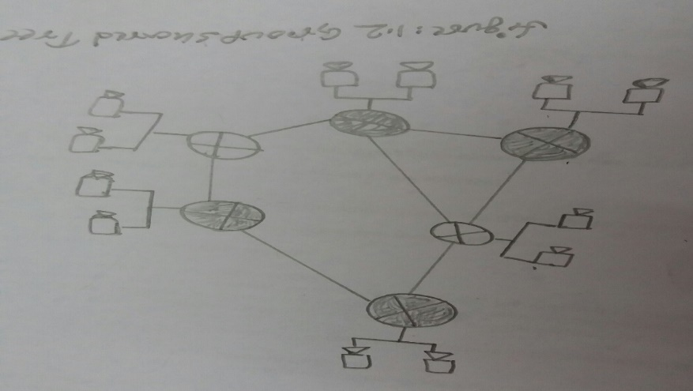

1. **SOURCE-BASED TREE: T**he multicast datagrams from a given source are routed over specific routing tree constructed for that source. However one tree per source: shortest path trees and reverse path forwarding. 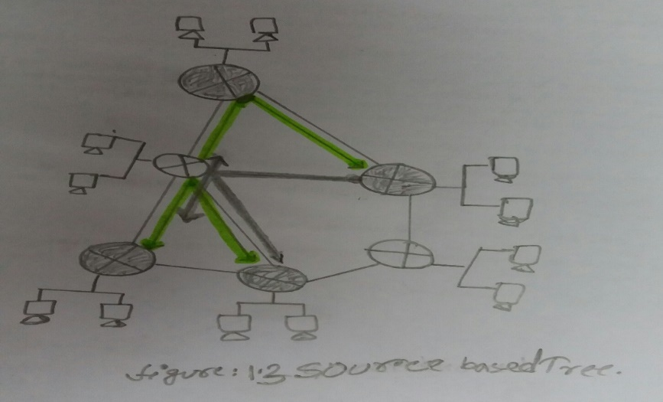

**33.** Consider the network below.



1. Suppose that this network is a datagram network. Show the forwarding table in router A, such that all traffic destined to host H3 is forwarded through interface 3.

b) Suppose that this network is a datagram network. Can you write down a forwarding table in router A, such that all traffic from HI destined to host H3 is forwarded through interface 3, while all traffic from H2 destined to host H3 is forwarded through interface 4? (Hint: this is a trick question.)

c) Now suppose that this network is a virtual circuit network and that there is one ongoing call between HI and H3, and another ongoing call between H2 and H3. Write down a forwarding table in router A, such that all traffic from HI destined to host H3 is forwarded through interface 3, while all traffic from H2 destined to host H3 is forwarded through interface 4.

D) Assuming the same scenario as (c), write down the forwarding tables in nodes B, C, and D.

1. Router A>enable, router # show cdp neighbors/show arp –a

Source is router A and Destination is H3 with interface is 3.

(b)

|  |  |
| --- | --- |
| Destination address | Interface |
| H3 | 3 |
| H3 | 4 |
|  |  |

(c)

|  |  |  |  |
| --- | --- | --- | --- |
| Incoming interface | Incoming VC | Outgoing Interface | Outgoing VC |
| 1 | 12 | 3 | 22 |
| 2 | 63 | 4 | 18 |
|  |  |  |  |

d) For Router B

|  |  |  |  |
| --- | --- | --- | --- |
| Incoming interface | Incoming VC | Outgoing Interface | Outgoing VC |
| 1 | 22 | 2 | 24 |

For Router C

|  |  |  |  |
| --- | --- | --- | --- |
| Incoming interface | Incoming VC | Outgoing Interface | Outgoing VC |
| 1 | 18 | 2 | 50 |

For Router D

|  |  |  |  |
| --- | --- | --- | --- |
| Incoming interface | Incoming VC# | Outgoing Interface | Outgoing VC# |
| 1 | 24 | 3 | 70 |
| 2 | 50 | 3 | 76 |

**34.** Consider a router that interconnects three subnets: Subnet I. Subnet 2, and Subnet 3. Suppose all of the interfaces in each of these three subnets are required to have the prefix 223.1.17/24. Also suppose that Subnet I is required to support up to 63 interfaces, Subnet 2 is to support up to 95 interfaces, and Subnet 3 is to support up to 16 interfaces. Provide three network addresses (of the form a.b.c.dlx) that satisfy these constraints.

Using 2n – 2. Start with subnet that has the highest hosts (i.e. subnet 2)

Subnet 2 (95 host):223.1.17.128/25(2n – 2 ≥ 95)

Subnet 1 (63 host): 223.1.17.0/25(2n – 2 ≥ 63)

Subnet 3(16 host):223.1.18.0/27(2n – 2 ≥ 16)

35.Suppose datagrams are limited to 1,500 bytes (including header) between source Host A and destination Host B. Assuming a 20-byte IP header, how many datagrams would be required to send an MP3 consisting of 5 million bytes? Explain how you computed your answer. (Assume the data is carried in TCP segment, with each TCP segment also having 20 bytes of header)

Here, Mp3 size=5 million byte=5*1000*1000byte and each datagram carry=1500-20=1480byte

We know, file size=5*1000*1000/1480=3378.37bytes.

36. are companies today providing a vedio on demand service over the internet using

a p2p architecture?

1.Suppose Alice ,with a web based email account(such as Hotmail or gmail),sends a message to Bob, who accesses his mail from his mail server using pop3.discuss how the message gets from Alice’s host to Bob’s host. Be sure to list the series of application layer protocols that are used to move the message between the two hosts.

Message is sent from Alice’s host to her mail server over HTTP. Alice’s mail server then sends the message to Bob’s mail server over SMTP. Bob then transfers the message from his mail server to his host over POP3.

2. Why would the token ring protocol be inefficient if a LAN had a very large perimeter?

Node transmits a frame: The node has to wait for the frame to propagate around the entire ring before the node can release the token. So if L/R is small as compared to tprop, then the protocol will be inefficient.

3. How big is the MAC address space? The ipv4 address space? The ipv6 address space?

MAC Address space is on $2^{48}$; Ipv4 address space is on $2^{23}$ and Ipv6 address space is on $2^{128}$

4.Why is an ARP query sent within a broadcast frame ?Why is an APR response sent within a frame with a specific destination MAC address?

There are several reason like:

* the querying host does not which adapter address corresponds to the IP address in question.
* As the sending node knows the adapter address to which the response should be sent,
* As a result there is no need to send a broadcast frame (which would have to be processed by all the other nodes on the LAN).